**Bicycle Exercise**

An exercise in object interaction

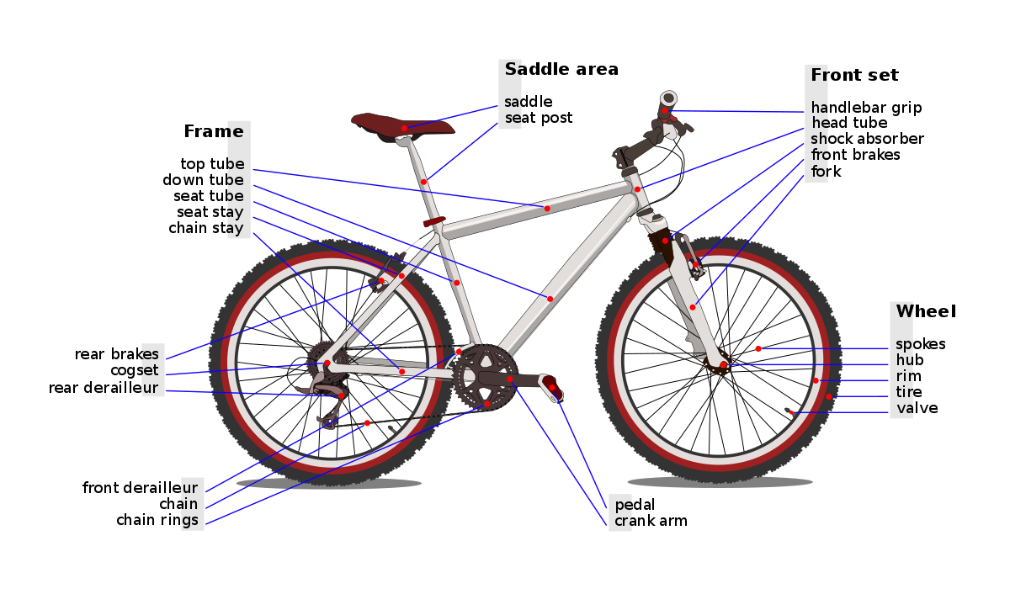

<https://upload.wikimedia.org/wikipedia/commons/thumb/8/8a/Bicycle_diagram-en.svg/1200px-Bicycle_diagram-en.svg.png>

After a thorough investigation of the illustration above, we conclude that bikes consist of:

Frame, fork, a wheel set, rear derailleur, front derailleur, brake set, handlebar, saddle (and some more components only experts care about).

Already, the example is growing too complex. Therefore, we further simplify the picture to:

* Frame
* Derailleurs
* Brakes

After a lot of system development steps we end up with the design class diagram (**Figure 1**).

1. Code the **Frame**, **Gear**, and **Brake** classes
   1. Make sure they work
2. Code the **Bicycle** class
   1. Pay attention to the **getPrice()** method – it does not correspond to an attribute!
   2. Also, make a nice **getDescription()** method.
      1. It should get all the relevant information from the parts (frame, derailleurs, brakes), and put it together in a nice description.
      2. Notice, it does not print anything. Why is that? How do we present the description to the user?

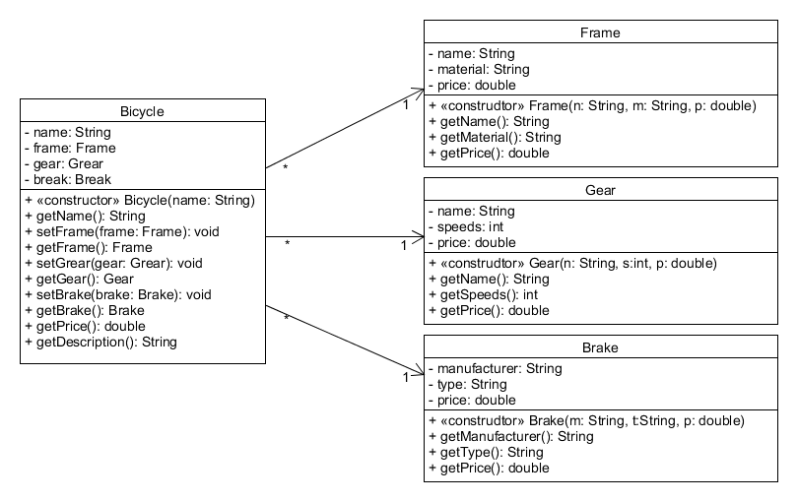

Figure : Design Class Diagram